**CONSENT AGENDA ITEM**

* Trustees voted electronically in August to approve a one-word modification to the College’s SACSCOC Notification of Changes policy, presented here for ratification. The College was required to submit the updated policy to SACSCOC by September 1. SACSCOC requires that this particular institutional policy encompass all types of possible changes, and has stated that policies that don’t cover the full range of possible changes will fall short. Trustees affirmed the recommended one word change, presented here for ratification, as follows:

*As required by the Southern Association of Colleges and Schools Commission on Colleges (SACSCOC), Central Carolina Community College shall report to the Commission written notification of all changes in curriculum offerings and facilities. Changes in college operations and services that substantially alter the way in which such operations are carried out or services are delivered ~~should~~ shall also be reported. … (CCCC Policies & Procedures Manual page 162)*

**SACSCOC HIGHLIGHTS**

* Amy Gustavson served as an evaluator for Institutional Effectiveness, Library, and QEP with a SACSCOC On-Site Evaluation committee for a community college in Mississippi in September.

**SACSCOC CORRESPONDENCE**

*SACSCOC Approves Submissions, Provides Guidance, Requests Information*

* July 5, 2019: SACSCOC approved the closure of the Shawtown Center (also known as the Lillington Adult Education Center) off-campus instructional site. CCCC sent a letter to SACSCOC requesting that they amend their records by officially closing the Shawtown Center curriculum instructional site. Documentation provided to SACSCOC in 2006 demonstrated that this site has only ever housed basic skills programming, thus should never have been listed as a curriculum site by SACSCOC.
* July 9, 2019: CCCC submitted the 2019 Financial Profile and Indicators to SACSCOC.
* July 25, 2019: Dr. Wheelan, President of SACSCOC, sent an email with updates and information, including the following:

The SACSCOC Board of Trustees approved a Differentiated Review Process for eligible institutions, which would potentially involve a less exhaustive reaffirmation process for institutions that had done very well with past reaffirmations. The eligibility requirements, standards, and processes will be rolled out in the fall, for implementation with the Class of 2023, pending approval by the full membership in December. We are hopeful that, given our good track records, we may be eligible to participate.

The Gen Ed Core Requirement wording for the Humanities requirement has been clarified adding the bold/underlined text below. It now states "Courses in basic composition that do not contain a **significant** literature component, courses in oral communication, and introductory foreign language courses are skill courses and not pure humanities courses. Therefore, for purposes of meeting this standard, none of the above may be the one course designated to fulfill the humanities/fine arts requirement in CR 9.3. **The institution is responsible for making a persuasive case that at least one of the courses it requires to meet the humanities/fine arts area does not "narrowly focus" on skills."** CCCC Humanities course requirements are in compliance with this clarified wording.

* July 30, 2019: In email correspondence with CCCC, SACSCOC Vice President Dr. John Hardt regarding SACSCOC Standard 14.2: Substantive Change, Dr. Hardt clarified that CCCC must provide a teach-out plan when a program is closing at one of CCCC’s locations even if the program remains open at other CCCC locations.
* August 26, 2019: CCCC submitted a letter and associated documentation to SACSCOC as requested in SACSCOC’s May 24, 2019 letter. The information documented that CCCC’s substantive change policy is written, approved, published, accessible, implemented, enforced on an ongoing basis, reviewed periodically and amended as needed. The information demonstrated the College’s compliance with SACSCOC Standard 14.2.
* September 16, 2019: SACSCOC acknowledged CCCC’s submission of the August 26, 2019 letter and associated evidence. These documents will be reviewed by the SACSCOC Board of Trustees at its December 2019 meeting.

**QEP HIGHLIGHTS**

*QEP Implementation Continues*

Quality Enhancement Plan team members continue to make progress on our *My Academic Pathway* project which is aimed at providing a personalized approach that enables new students to make efficient, effective, and timely choices in order to complete their educational and career goals. The essential elements of the project are providing enhancements to Admissions, ACA courses, and Advising. The project goals are to:

1. Enable each student to select an appropriate academic program,
2. Consistently enhance each student’s pathway to goal completion, and
3. Facilitate timely completion of each student’s academic goals.

Highlights this quarter include:

* Amy Gustavson, Assistant Director of Institutional Effectiveness & QEP, shared highlights of the QEP’s two-year progress at the Learning & Workforce Development Division meeting on August 14, 2019.
* The QEP Marketing Team was busy this quarter. They created a *My Success Checklist* and Students Services guides to help students navigate their first semester. These resources are now available on the [CCCC Advising website](https://www.cccc.edu/advising/current-students/) under Current Students.

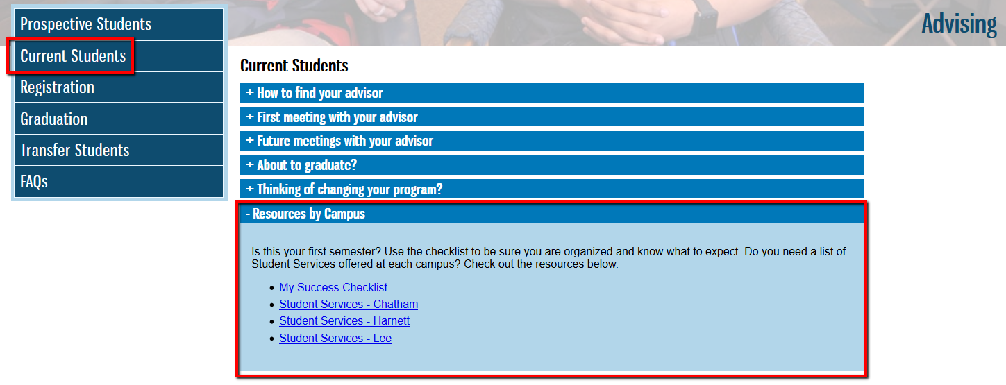

The QEP Marketing Team also held a MAP Refuel event during the second week of classes. Students were treated to mochas and delicious shortbread cookies on the Chatham, Harnett, and Lee main campuses. Students received a copy of the *My Success Checklist* and *Student Services* guide for their campus. Faculty and staff volunteers reviewed the importance of completing tasks each semester in order to ensure that students stay on their pathway and complete their academic journey. Students were excited to receive the treats and handouts. One Lee Main Campus student said “This is the best day ever. A Monday, and I get mocha and cookies?!”

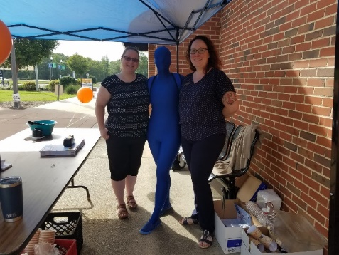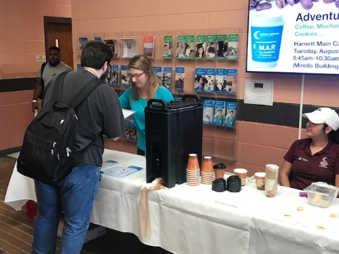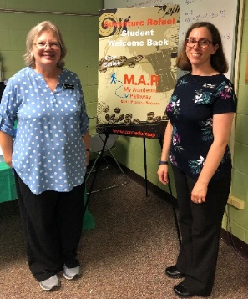

* The QEP ACA Team chair, Seth Buchanan, and QEP Advising Team chair, Maryann Aucompaugh, provided a MAP professional development session to CCCC advisors on October 11, 2019. They updated advisors on the way advising is taught in ACA 122.
* The QEP Admissions Team is planning a Fall focus group with students who were referred to Developmental Faculty Member or a Career Counselor to get career support. Upon enrollment, students take the Embark: Career Interest Inventory. The Career Decision Inventory (CDI) portion of the assessment identifies a student’s confidence with their career choice. If they’re not confident, they work with a Developmental Faculty Member or a Career Counselor to have more in-depth career conversations.

The QEP Admissions Team is also planning a Fall training and check-in meeting for the Developmental Faculty Members and Career Counselor. They will discuss how the referral process is going and how to best support referred students.

* The QEP Advising Team provided advising training to 60 adjunct instructors on CCCC’s Adjunct Night on August 14, 2019. This team is also planning a series of in-person advising training sessions throughout 2019-20. They will include presentations by CCCC advisors and NACADA webinars.
* The QEP Advising Team continues to revise the Foundations of Advising (advisor training) course based on advisor feedback. The current course will be split into one course for new advisors and a second course for established advisors. An annual refresher course is also being created. The courses will be piloted in Fall 2019 and go live in Spring 2020.
* The Success Council bid farewell to chair Amber Thomas. Her enthusiasm and student-centered focus will be missed! Shawna Jones is the new Success Council Chair! Shawna has been employed at CCCC since Fall 2013, first as an adjunct English Instructor, and later as a full-time English Instructor starting in February 2015. She holds a Bachelor’s degree in English and a Master’s degree in American Literature from N.C. State University. She looks forward to leading the Success Council! The group is comprised of CCCC students, staff, and faculty in Chatham, Harnett, and Lee counties.
* The QEP Assessment Team continues to review QEP assessment metrics and results. The group is started to focus on 2019-20 assessment planning.

*Selected 2018-19 QEP Assessment Results:*

* + 85% of students from the 2018 QEP Cohort enrolled in an ACA course in the 2018-19 academic year.
  + 76% of students successfully passed ACA 122 in 2018-19! Now we’re raising the bar! Our new goal is for 80% of students to successfully pass ACA 122 in 2019-20.
  + 83 students from the 2018 QEP Cohort completed the 2018FA Student Advising Survey during the Fall 2018 midsemester rollout.

**STRATEGIC PLANNING AND GPS**

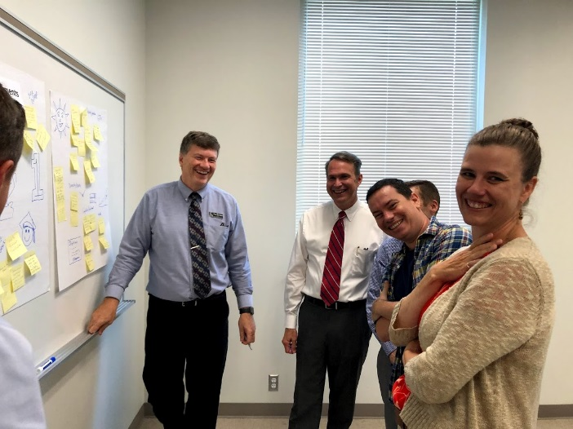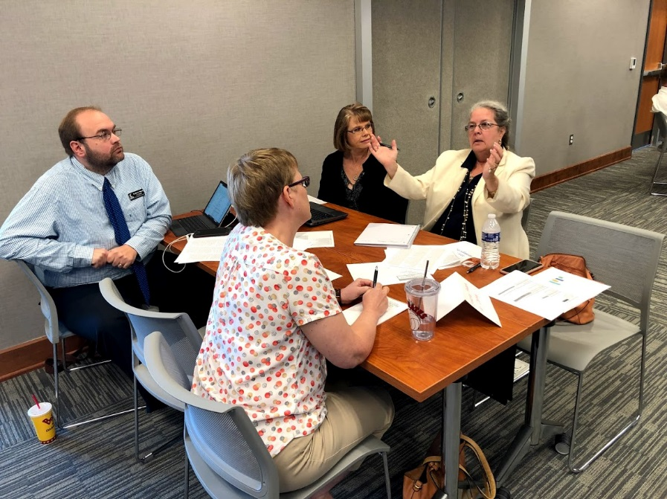The Planning Council continues to meet regularly to craft our 2020 strategic plan. At recent meetings we have taken a deep dive into our institutional data, reorganized institutional goals/focus areas, and developed new objectives. We also drafted a new Vision statement after inviting input from all employees. *Below: Planning Council members envisioning an exciting future for CCCC!*

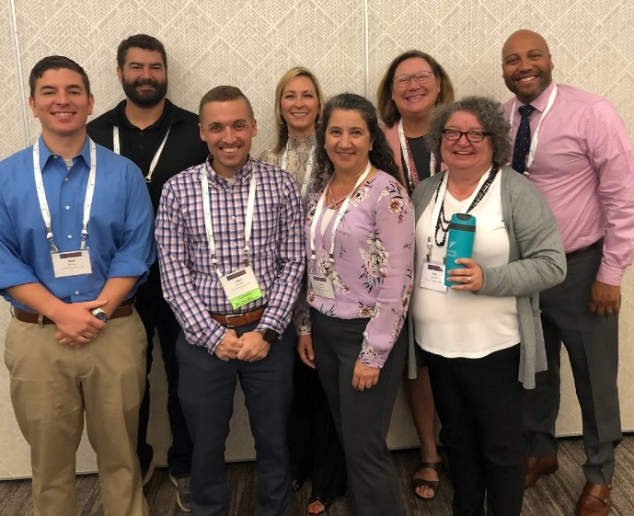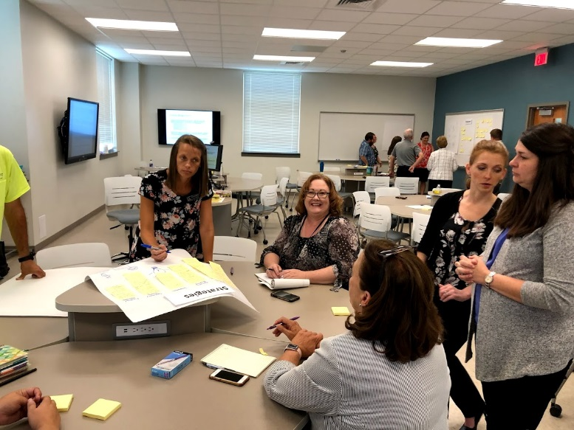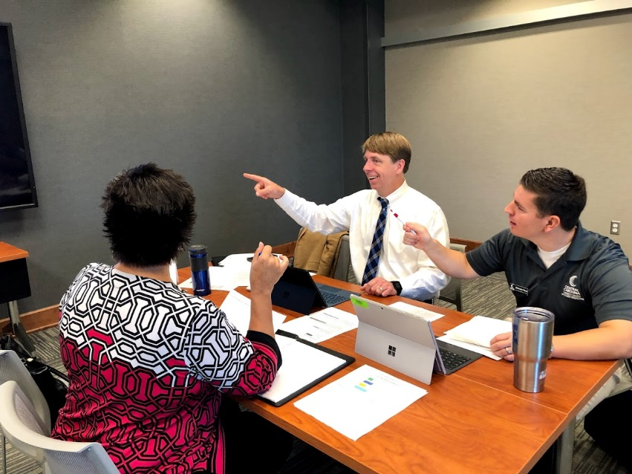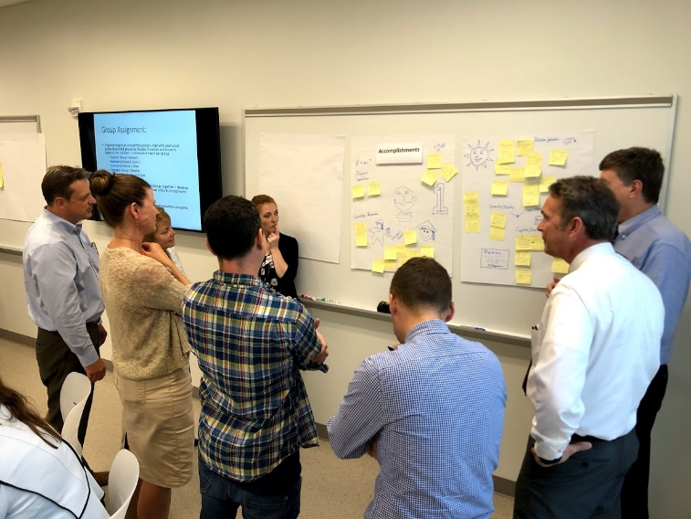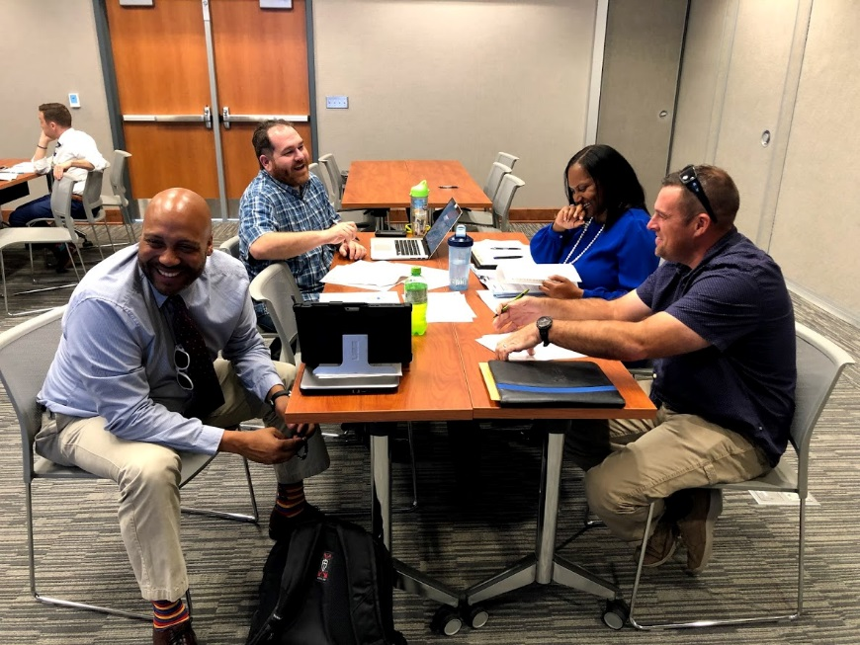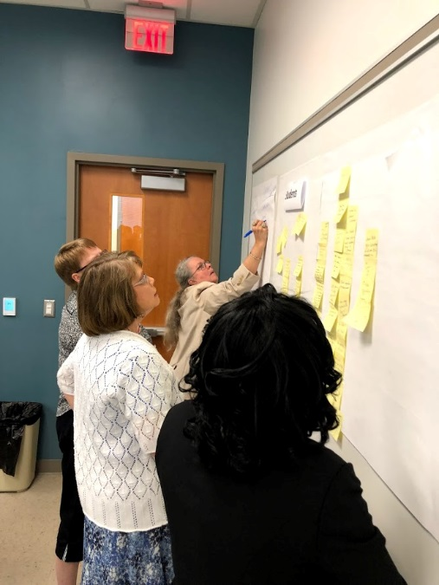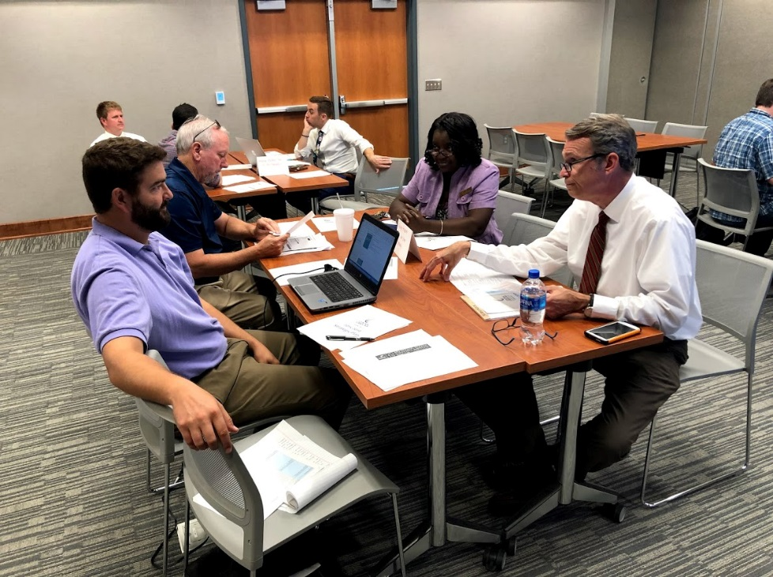

Given our focus on Equity, a team of eight planning council members participated in the grant funded *Achieving the Dream* Holistic Student Supports Design Institute in Chicago the first week in October. With the help of an expert facilitator, the team identified critical issues and developed multiple solutions which will be integrated with the planning process.

*At right: Achieving the Dream* Holistic Student Supports Institute participants Nick Testa, Jon Spoon, Adam Wade, Melissa Fogarty, Lora Witcher, Linda Scuiletti, Pam Riddle, Jairo McMican.

*Updated Key Performance Indicators (KPIs) from 2015-19 Strategic Plan*

Over the course of our 2015-19 *Learning First* strategic plan, we’ve seen a 216% increase in the number of students coming to CCCC after high school having already earned prior Central Carolina curriculum credit:

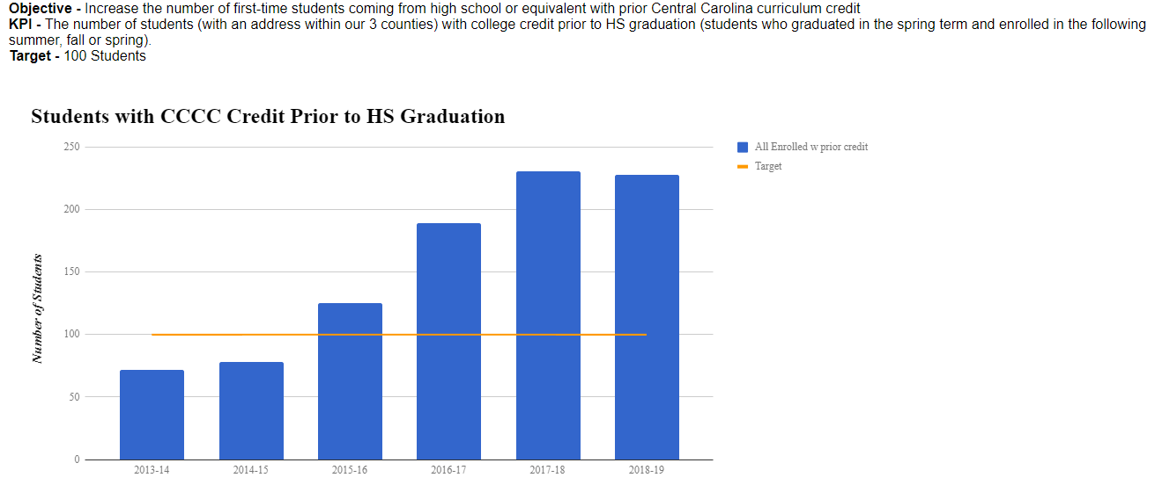

**IPEDS**

The Integrated Postsecondary Education Data System (IPEDS) is a system of surveys conducted annually by the US DOE’s National Center for Education Statistics (NCES).   All institutions that participate in Title IV federal financial aid programs are required to submit information.  This information is available to students, parents and the general public through College Navigator as well as several other sites which use IPEDS data. Congress, federal agencies, state governments, education providers, professional associations, private businesses, media, students and parents can utilize IPEDS data to gather information on various institutions.

Data collection for the 2019-20 reporting periods is now open. The Fall collection is currently being completed and consists of Institutional Characteristics, Completions and 12-month enrollment. To view the full custom data feedback report or data from previous years, you can access the IPEDS datacenter at <http://nces.ed.gov/ipeds/datacenter/>.

**PARTNERING for SUCCESS ACROSS THE STATE**

* Director of Institutional Effectiveness & Research Stormy Mascitelli was tapped by the NCCCS Success Center and the NC Guided Pathways to Success (GPS) initiative to develop data solutions for all NC GPS community colleges. She recently completed development of data dashboards for ten colleges that disaggregate student success data by race/ethnicity, gender, age, and instructor. In phase two she is working with CCCC’s Institutional Research Analyst Christi Copes to implement these solutions at an additional 15 colleges.
* Linda Scuiletti continues to serve on the statewide NC Community Colleges Performance Partnership Advisory Team. The Team hosted another sold-out Performance Partnership Summit in July, at which representatives from high-performing colleges shared student success strategies with their colleagues from all 58 NC community colleges.

At this year’s Summit, Dr. Scuiletti co-presented two keynote sessions with Dr. Karen Oehme of Florida State University. The sessions focused on the long-term impacts of Adverse Childhood Experiences (ACEs) on learning and well-being; and practical skills for helping students develop resilience, confidence, self-efficacy, and stress-management tools. Dr. Oehme is a national expert in the study of Adverse Childhood Experiences and led Florida State’s team in developing a highly successful on-line solution to address these issues for their own students.

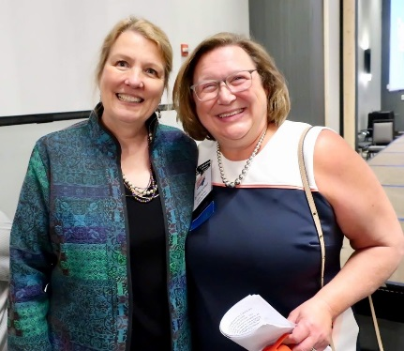

*Dr. Karen Oehme of Florida State University, with CCCC’s Linda Scuiletti*

**INSTITUTIONAL RESEARCH**

*Institutional Data*

The IER department has continued to support the college community by providing data and analysis by request to assist areas within the college in making data informed decisions. Recent requests have included things such as, retention, success rates, enrollment, FTE, success comparison, program data and equity data.

With our focus on Equity/Inclusion, we offer some interesting data on our CCCC students:

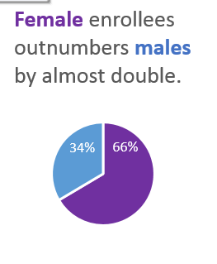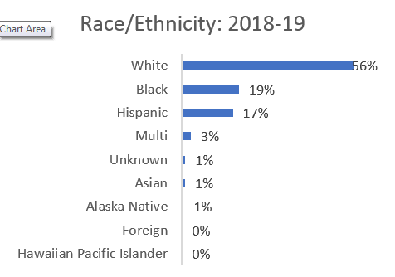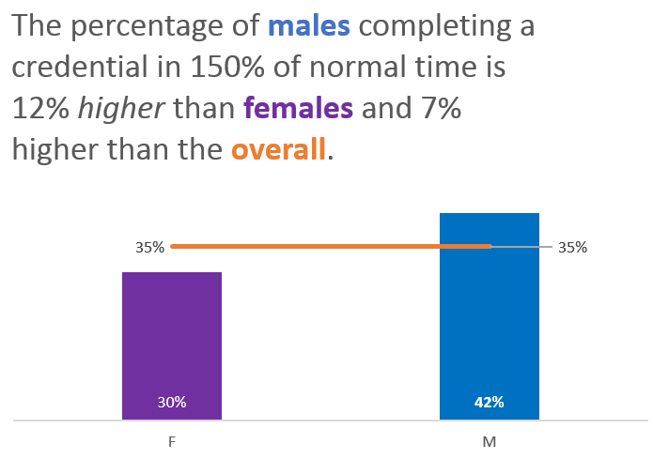

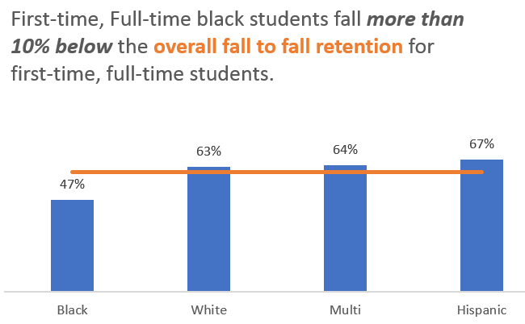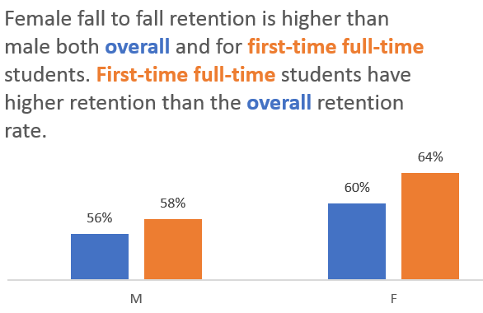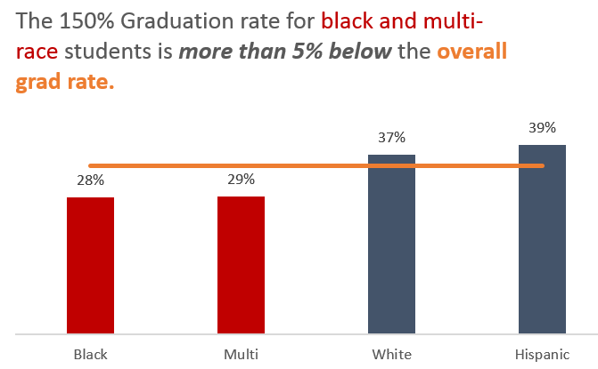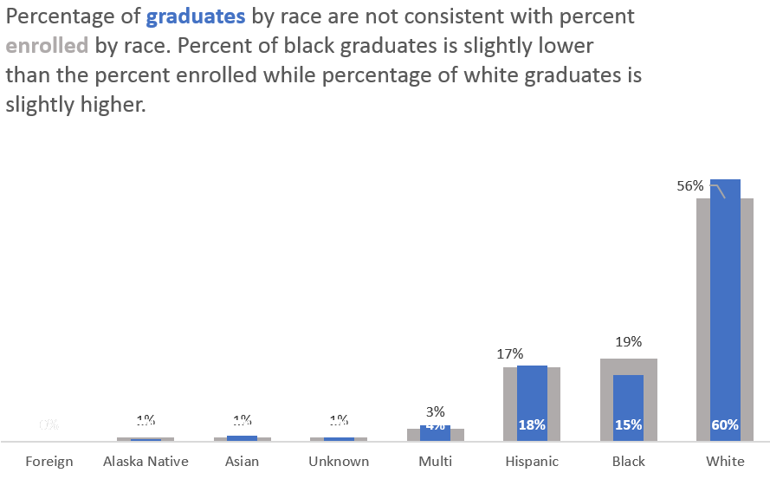

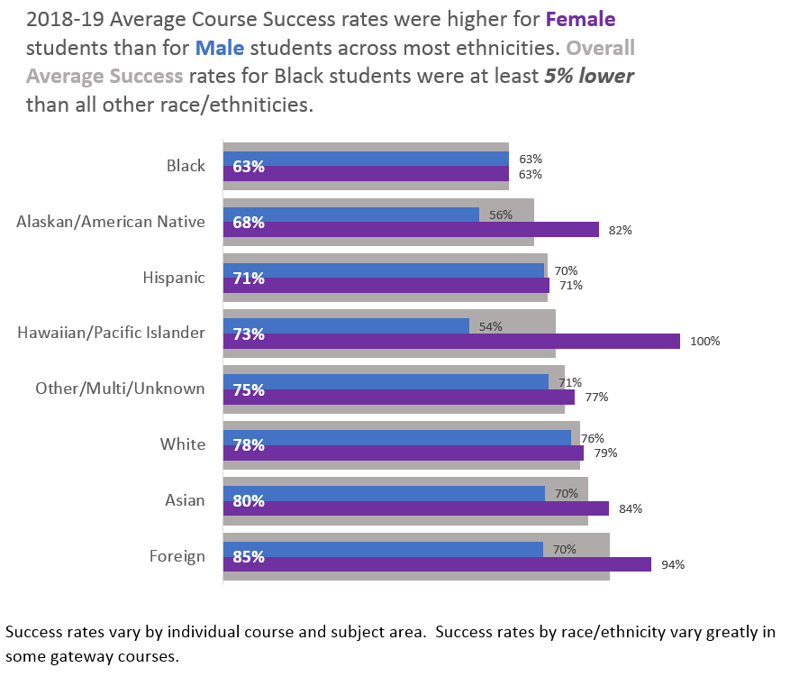

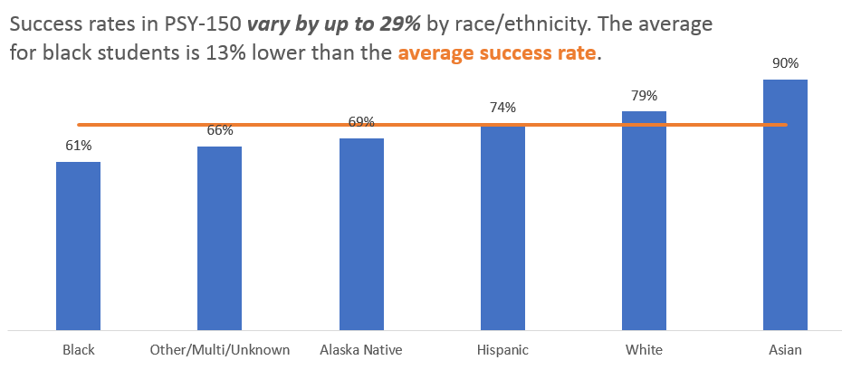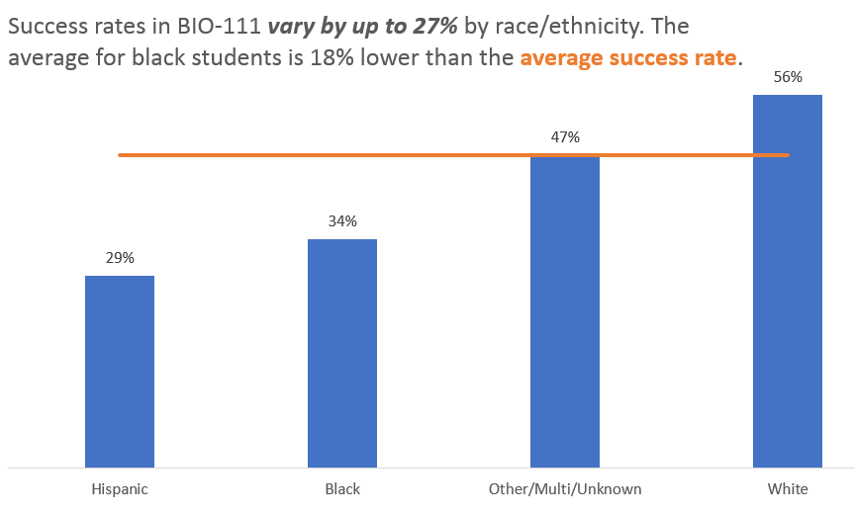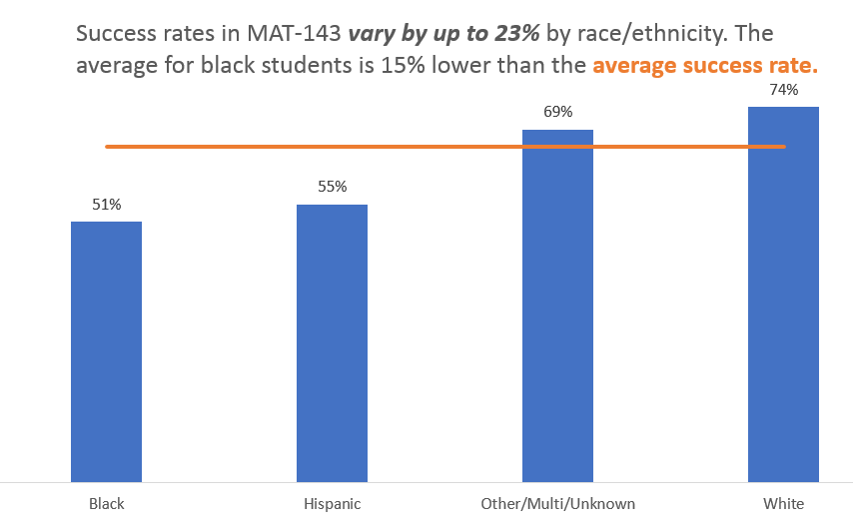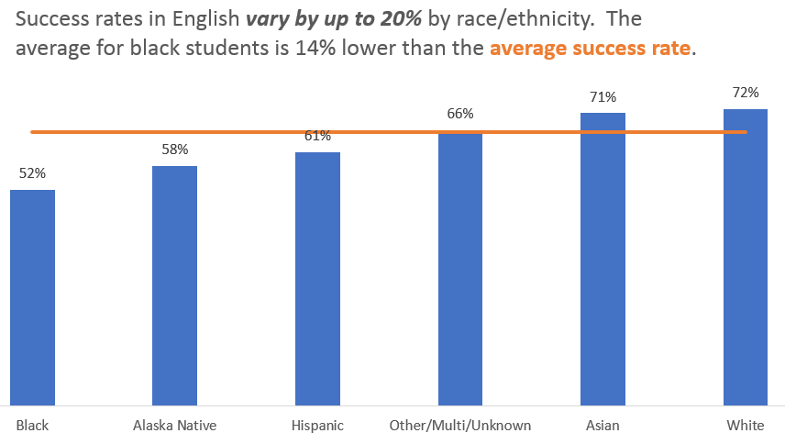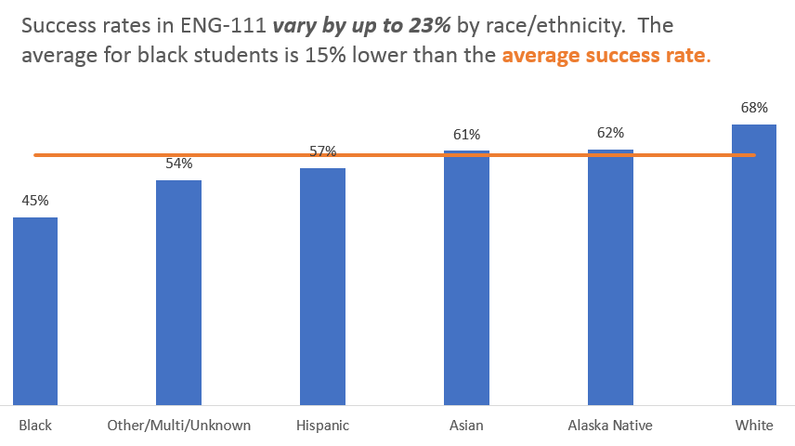

*Finish First*

The IER department, in partnership with the student learning division, has deployed a new grant-funded audit tool that identifies students who are close to earning any credential or have already earned one but not applied for it. Using the *Finish First* audit tool, each term IER creates the following lists:

* **Potential Graduates** not currently enrolled and didn’t apply to graduate:
  + Students who *appear to have* earned a credential but never applied to receive it and are not currently enrolled
  + Tool checks EVERY student enrolled for the specified terms against EVERY possible credential we offer in the current catalog
* Students **within One Semester** of graduating and not currently enrolled (many only need 1 credit or 1 class):
  + Run for multiple last academic years of attendance
  + Resulting spreadsheet shows exactly which classes are still needed
  + Some students may have already completed a credential based on a previous catalog (putting them in Group 1 above)

Results from the first several deployments of this tool identified hundreds of students who had earned a credential but never applied for graduation. The Registrar’s office validated the findings and reached out to all identified students to make arrangements for awarding their credentials.

*2019-20 Fact Book*

The 2019-20 Fact Book has been completed and printed. A printed copy will be available to you and an electronic version will be posted on the IER website. Moving forward, the Presidents Council agreed that with the development of the new dashboards, the annual Fact Book could be condensed down to a 2-page information sheet. This will begin for the 2020-21 academic year.

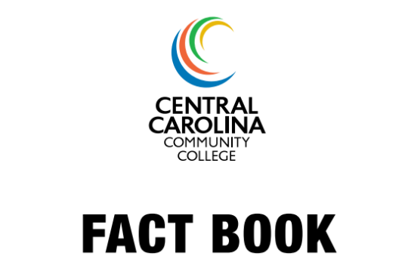

[*Data Dashboards*](http://www.cccc.edu/intranet/data-dashboards/)

The CCCC [data dashboards](http://www.cccc.edu/intranet/data-dashboards/) continue to be widely used. These dashboards are designed to provide data updated daily and allow users to drill down and filter the data as they choose.

* The CCCC Data Dashboards are available on the intranet and now include:
  + 2019 Fall Course fill and Retention Report
  + 2019 Fall Enrollment
  + 2019-20 Estimated FTE
  + Credentials Awarded
* Additional dashboards are being created for individual departments by request. Examples of these include a withdrawal dashboard and a dashboard showing application vs enrollment by high school.

*Annual Surveys*

* An ad hoc committee has been convened and is reviewing and updating all annual institutional surveys. The initial focus is on student surveys and will then continue to review employee surveys.
* A Student Financial Wellness Survey, administered by Trellis, will be conducted this fall. This survey will be done at no cost to the college and will give us a more thorough understanding of the financial wellness of our students. In addition to the summary report for the college, we will receive benchmarked data from institutions similar to CCCC.
* The annual Enrolled Student Satisfaction survey has been revised and will now be administered during the Fall term. This will allow us to obtain feedback from the largest number of students and potentially make improvements for the following term.
* The Applied but Did Not Enroll survey has been administered and initial results have been shared. Full results will be shared with the Presidents Council soon.